10M/100M Ethernet Media Converter

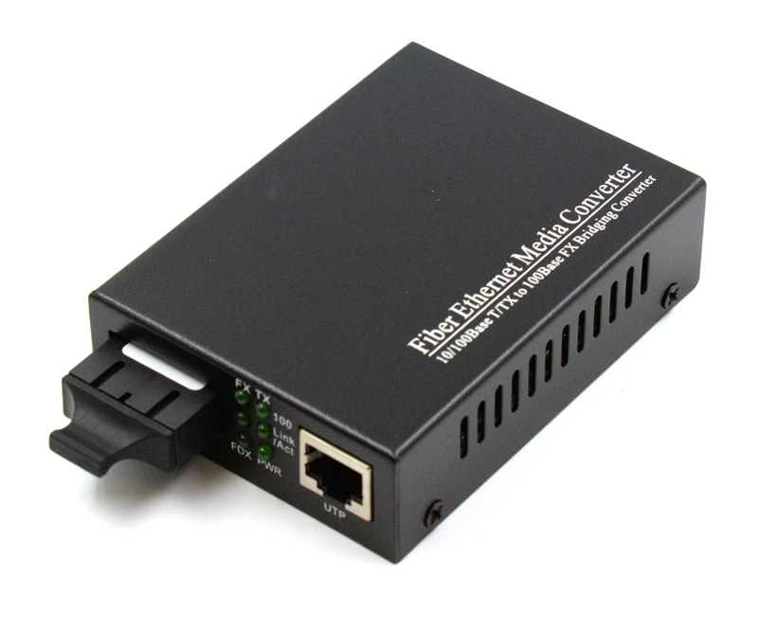

Features:

Comply with IEEE802.3 IEEE802.3u ,IEEE802.3x and 10 Base-T,100Base-Tx,100Base-Fx
TP-port rate 10M/100M auto negotiation
Offer Tx,Rx,100M,PWR,FDX,LINK/ACT indicators on the front panel
Offer single RJ-45 port MDI/MDIX auto-crossover.
Surface Mount Technology
Can be used as a slide in module to the 19¡±converter rack or standalone
MTBF:50,000 hours

Specification:

Ethernet Port:
Connector: One RJ45(Female),
Rate:10/100M bps
Full/Half duplex auto-adaptive ,MDI/MDI-X

Optical Port:
Connector: ST/SC/FC optional
Wavelength: 850 nm for multimode
1310nm or 1550nm for singlemode

Working Temperature: 0-50¡æ
Storage temperature; -40-70¡æ
Humidity: 5-90%(non-condensing)
Power Supply: External, AC 100V-260V, DC 5V 1A (Inner power supply available upon request)
EMI: FCC Class A CE Mark
Standalone type Size: 133mm(L)*70mm(W)*26mm(H)

Order Information

Part No | Description of product
Standalone series
WT-OTE-1315DKT | 10/100M bps,Mulitmode,850nm,0-2KM,SC,Standalone
WT-OTE-1315DMKT | 10/100M bps,Mulitmode,1300nm,0-2KM,SC, Standalone
WT-OTE-1315DMKT+ | 10/100M bps,Mulitmode,1310nm,0-5KM,SC, Standalone
WT-OTE-1315DKTS -25 | 10/100M bps, Single mode,1300nm,0-25KM,SC, Standalone
WT-OTE-1315DKTS -40 | 10/100M bps, Single mode,1300nm,0-40KM,SC, Standalone
WT-OTE-1315DKTS -60 | 10/100M bps, Single mode,1300nm,0-60KM,SC, Standalone
WT-OTE-1315DKTS -120 | 10/100M bps, SM,1550nm(DFB laser),0-120KM,SC, Standalone
Card series
WT-OTE-1315DK | 10/100M bps,Mulitmode,850nm,0-2KM,SC,Card
WT-OTE-1315DKS -25 | 10/100M bps, Single mode,1300nm,0-25KM,SC, Card
WT-OTE-1315DKS -40 | 10/100M bps, Single mode,1300nm,0-40KM,SC, Card
WT-OTE-1315DKS -60 | 10/100M bps, Single mode,1300nm,0-60KM,SC, Card
WT-OTE-1315DKS -120 | 10/100M bps, SM,1550nm(DFB laser),0-120KM,SC, Card

